**Investigating Non-Invasive Biomarkers and Risk Factors Associated with Liver Cirrhosis**

**1. Introduction**

Cirrhosis refers to the scarring of liver tissue which occurs as a result of long-term damage sustained by various chronic liver diseases and conditions [1,2](https://www.zotero.org/google-docs/?bEWnj8). Predominantly, these diseases include viral hepatitis (specifically HBV & and HCV), alcoholic liver disease (ALD), and non-alcoholic fatty liver disease (NAFLD) [1,3,4](https://www.zotero.org/google-docs/?oQhsuD). Disease progression varies based on the underlying cause, the presence or absence of treatment, and ongoing liver injury. In advanced stages, liver cirrhosis can affect and compromise the proper functioning of the liver due to long-term damage, with these effects potentially becoming irreversible and life-threatening [4](https://www.zotero.org/google-docs/?0U2qzg).

Although ranking as the 11th overall leading cause of death and 3rd leading cause of death in people aged 45-64 years in 2021, liver cirrhosis lacks an enhanced cure [5](https://www.zotero.org/google-docs/?hQKV1h). Current treatments are focused on symptomatic relief and slowing down disease progression for individuals with mild to moderate severity. In severe cases, where the liver is significantly damaged, liver transplant remains the primary treatment option [1](https://www.zotero.org/google-docs/?ow2G7c).

Recognizing the need for innovative therapeutic approaches, there is an urgent need to explore non-invasive biomarkers and identify risk factors associated with liver cirrhosis to advance our comprehension of the disease[2](https://www.zotero.org/google-docs/?Dc9l6F). In this exploration lies the potential to unravel the intricate relationship between liver health and the gut microbiome, a connection that has recently been implicated in numerous diseases[1,3,6](https://www.zotero.org/google-docs/?gwELIz).

Studies involving patients with different levels and types of liver disease were conducted to observe the changes in the microbiota over time and during disease progression. In 2011, Yan et. al presented their findings in observing gut dysbiosis in mice with ALD using 16S rRNA sequencing, highlighting intestinal bacterial overgrowth in diseased mice [7](https://www.zotero.org/google-docs/?kmtiIm). In 2013, Bajaj et. al investigated these changes using pyrosequencing techniques and ribosomal taxa analysis and reported significant differences in the gut microbiota of patients with cirrhosis compared to those without [8,9](https://www.zotero.org/google-docs/?K0ntfI). Subsequently, Loomba et. al (2017) set out to establish gut microbiota-derived signatures to predict the presence of advanced fibrosis and characterized the association between the severity of fibrosis in NAFLD patients, and gut dysbiosis [10](https://www.zotero.org/google-docs/?RrElqq). However, most studies that exist in the existing literature rely on 16S rRNA sequencing, offering limited insights compared to the holistic view provided by metagenomic shotgun sequencing [11](https://www.zotero.org/google-docs/?ZNHbkg).

To comprehensively investigate non-invasive biomarkers and identify risk factors associated with liver disease, a thorough analysis of the gut microbiome is imperative. This necessitates using extensive sequencing techniques, such as whole metagenome shotgun sequencing, to capture the complete microbial landscape and enable a more nuanced understanding of the relationship between liver cirrhosis and the gut microbiome.

This report aims to explore non-invasive biomarkers and potential factors associated with liver cirrhosis using the comprehensive data obtained through whole metagenome shotgun sequencing as collected by Qin et al (2014) [2](https://www.zotero.org/google-docs/?vHkPH7).

**2. Methods**

**2.1 Sample Data**

A total of 97 subjects (NC = 43, ND = 54) participated in this study. The diagnosis of liver cirrhosis in affected subjects adhered to international guidelines, including the requirement of a biopsy. Borderline or inconclusive cases were excluded from the diseased population[2](https://www.zotero.org/google-docs/?sf3ap7). Additionally, individuals with hypertension, diabetes, metabolic syndrome, inflammatory bowel disease (IBD), NAFLD, coeliac disease, and cancer were excluded from the control group. Figure 1 presents additional characteristics of the participants involved. Stool samples from each subject were collected and a DNA library was constructed according to Illumina instructions to perform whole metagenomic shotgun sequencing. The same workflows from Illumina were then used to perform whole metagenome shotgun sequencing, and reads that mapped to the human genome, along with their mated/paired reads, were eliminated from each sample using BWA with ‘-n 0.2’.

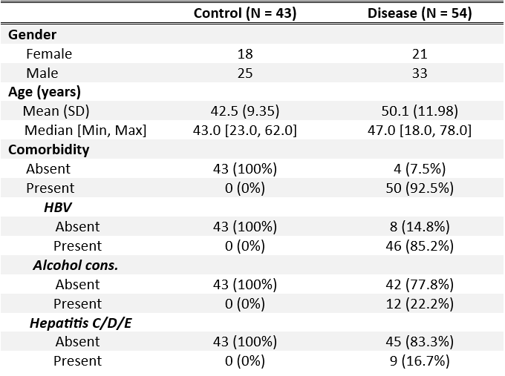

**Figure 1 -** Participant Characteristics (based on [2](https://www.zotero.org/google-docs/?R2k9SR))

Following additional quality control measures, raw metagenomic taxa were quantified using MetaPhlAn4. To achieve this, MetaPhlAn4 compares the acquired reads with a curated database consisting of 1.01 million prokaryotic reference and metagenome-assembled genomes. The reads that match these marker genes are then identified and quantified within the sample, and each fragment is assigned a taxonomic label according to the match [12](https://www.zotero.org/google-docs/?qXY1tC).

Further downstream analysis and visualization was conducted in R (version 4.3.1), using the vegan, ecodist, fossil, and ggplot2 packages.

**2.2 Statistical Analyses**

**2.2.1 Diversity Analysis**

Alpha and beta diversity analyses were conducted to evaluate diversity within each sample and group. In alpha-diversity analysis, relative abundance values of species were evaluated using the Shannon, Simpson, and Chao1 metrics, providing insights into species richness, evenness, and estimated total richness. For beta-diversity analysis, Bray-Curtis dissimilarity scores were used to quantify the dissimilarities between control and disease patients, and these results were visualized using Principal Coordinates Analysis (PCoA).

**2.2.2 Differential Abundance Analysis**

Differential abundance analysis across different groups was conducted firstly by evaluating relative abundance at both species and genus levels to identify the key contributors to liver disease. The Wilcoxon rank-sum test was applied to these taxa, to subset those with p < 0.05. To further refine the subset, mean relative abundance values for each taxon were calculated to display those that had the highest values and categorize the rest as ‘Others’. It is important to acknowledge the trade-off of this approach - focusing on highly abundant taxa provides a comprehensive view of significant contributors to liver disease but sacrifices information on less abundant key players.

Then, the differences in mean relative abundances for species with p < 0.05 were computed to provide insight into species-level changes observed in liver disease patients versus control patients. The top 20 species with the most significant absolute changes in mean relative abundance were then displayed, along with their means, and key species were identified.

Finally, relative abundance analyses for the identified key species were performed to confirm their significance. Differences across different health states were observed, and the Wilcoxon rank-sum test was applied to assess the statistical significance of these variations.

**2.2.3 Analysis of Confounding Variables**

To assess the impact of associated factors in liver disease, analyses of age, gender, body mass index (BMI), albumin (Alb), creatinine (Crea), total bilirubin (TB), and hepatitis B virus (HBV) were performed using alpha diversity & Model for End-Stage Liver Disease (MELD) scores.

Shannon and Simpson metrics were employed to calculate alpha-diversity for each factor, and Spearman’s correlation coefficients were used to determine the relations between the listed factors, diversity, and MELD scores.

**3 Results**

**3.1 Diversity of the Gut Microbiome in Liver Disease**

Gut microbiome diversity for each sample was assessed through alpha-diversity, employing the Simpson, Shannon, and Chao1 metrics. The analysis of these findings unveils a distinct decrease in microbial diversity within the gut of the diseased group across various metrics (Figure 2).

Figure 2 provides valuable insights into the precision of each metric in calculating alpha diversity for this dataset. Upon reviewing the p-values calculated by the Wilcoxon rank-sum test for each metric, it can be concluded that both the Simpson and Shannon metrics are suitable for this dataset. The Simpson metric accounts for the dominance of a few abundant species, while the Shannon metric considers both the number and evenness of species. The Chao1 metric, however, exhibits a significantly high p-value, especially in comparison to the other metrics. The p-value associated with the Chao1 index substantially exceeds the conventional threshold of p = 0.05 used to assess statistical significance, suggesting that Chao1 may not be a sufficient metric for accurately characterizing the alpha-diversity in this dataset.

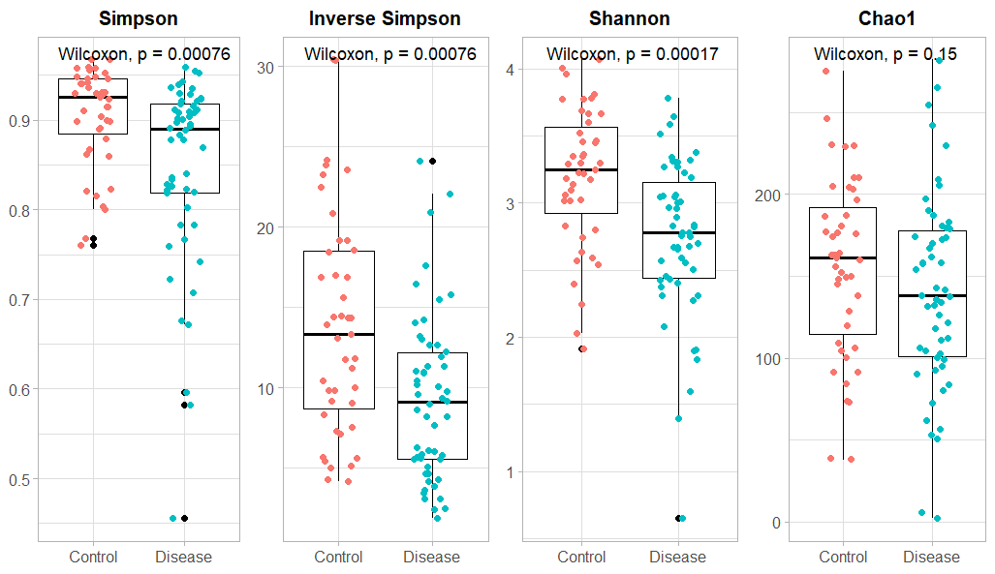

**Figure 2 -** Boxplot representation of the alpha diversity of the gut microbiome across control and disease groups, using Simpson, Shannon, and Chao1 indexes (and Inverse Simpson for visual convenience). P-values were calculated using the Wilcoxon rank-sum test.

The assessment of gut microbial diversity across groups was implemented using the Bray-Curtis dissimilarity score and PCoA. Figure 3 showcases the results obtained from these calculations, and provides insights into how microbial community structures differ with the absence and presence of liver disease.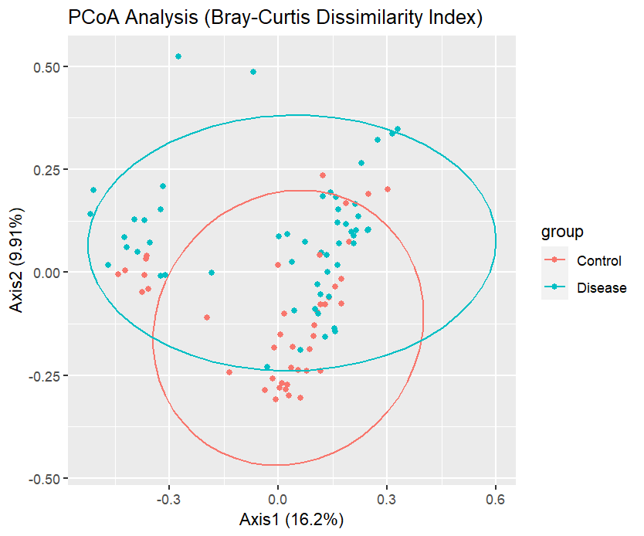

**Figure 3** - PcoA plot of Bray-Curtis dissimilarity of control and liver disease groups with 95% confidence ellipses. Each dot represents a measure of the microbiome composition of a given sample.

The tight clustering that can be observed in the healthy samples suggests a similarity in microbial compositions within this group. In contrast, the dispersion of points representing diseased samples indicates higher variability in their microbial composition. The increased microbial variability observed in the diseased samples may suggest the presence of gut dysbiosis and could offer insights into the severity of the disease.

**3.2 Identification of Key Species in Liver Disease**

Differential abundance analysis was conducted on the genus and species data to pinpoint key species associated with the occurrence and progression of liver disease. In Figure 4, the taxa with the highest mean relative abundances are displayed at a genus and species level. While genus-level analysis facilitates the identification of the major groups present in the community and offers a broader perspective, species-level analysis offers a more detailed view and aids the identification of some potential key players in liver disease.

A) B)

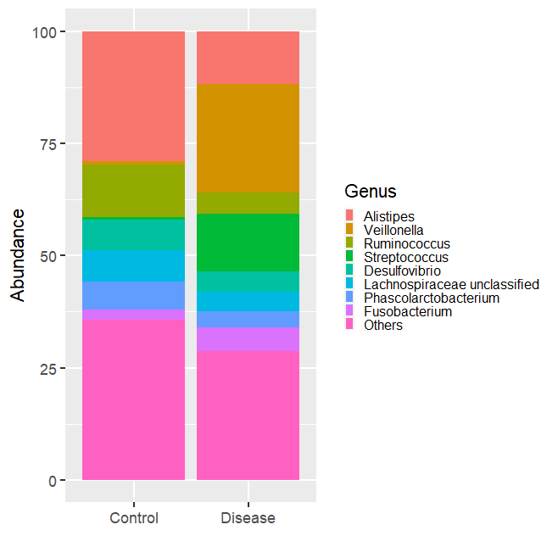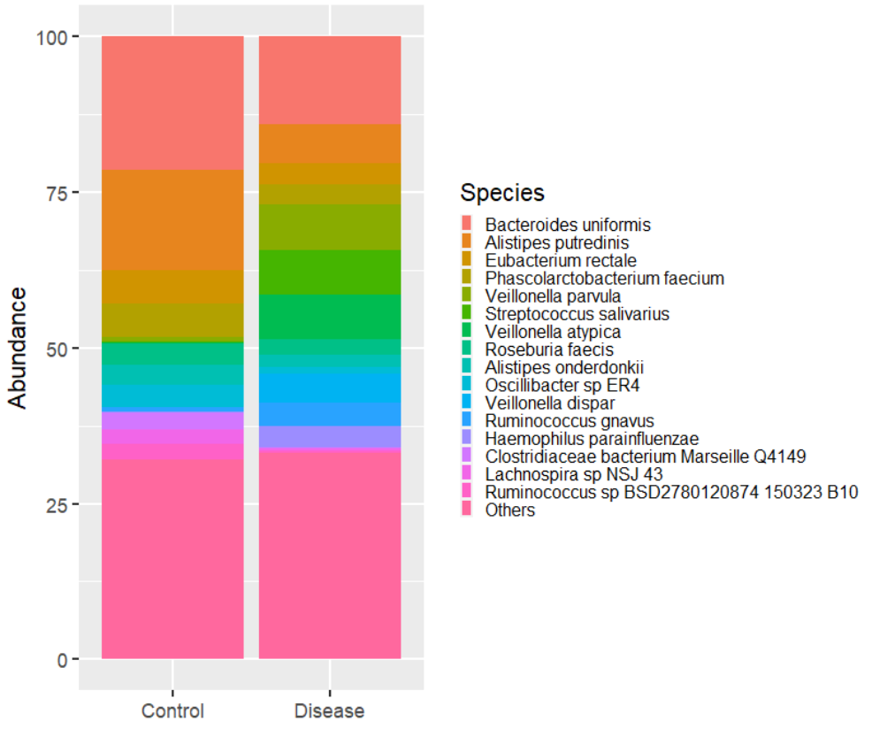

**Figure 4** - A) Stacked barplots representing the mean relative abundance of genera present in liver disease and control patients B) Stacked barplots representing the mean relative abundance of species present in liver disease and control patients

Examining the genus-level data reveals a notable rise in the *Veillonella* and *Streptococcus* genera, accompanied by a decline in the *Alistipes* genus among patients with the disease. Similarly, at the species level, we observe an upsurge in *Veillonella parvula*, *Veillonella atypica*, and *Streptococcus salivarius*, coupled with a reduction in *Alistipes putredinis* within the diseased group. Additionally, though not apparent in its genus counterpart, a significant decrease in *Bacteroides uniformis* is evident in this plot.

The species demonstrating the most significant shifts in mean relative abundance during disease progression were graphically represented, along with the mean differences, aiming for a more precise identification of the pivotal species in liver disease (Figure 5). By cross-referencing this information with the relative abundance figure presented above, we can narrow down the list of key species to include *Alistipes putredinis*, *Bacteroides uniformis*, *Veillonella parvula*, *Streptococcus salivarius*, and *Veillonella atypica*.

When plotted, the relative abundance of these species reveals their significant association with liver disease, as evidenced by the corresponding p-values derived from the Wilcoxon rank-sum test (Figure 6).

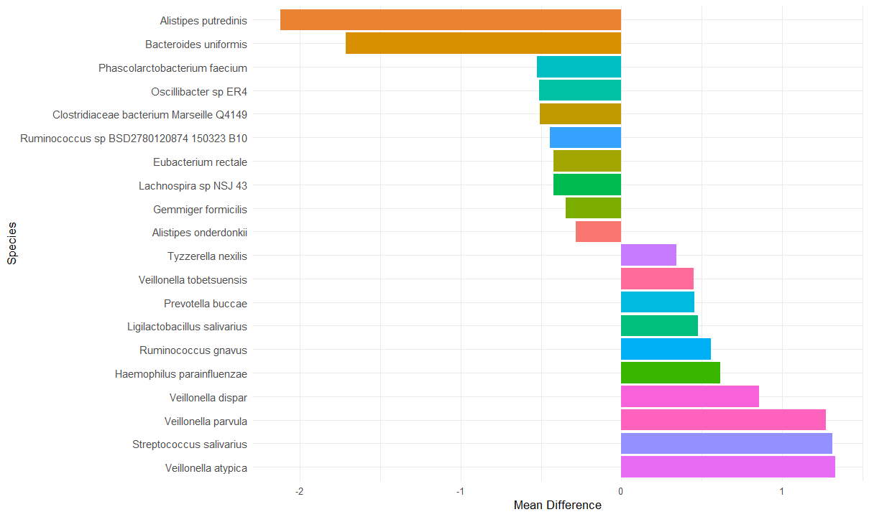

**Figure 5** - Barplots illustrating species with the highest differences in mean relative abundance, accompanied by the corresponding mean difference values calculated as disease minus control.

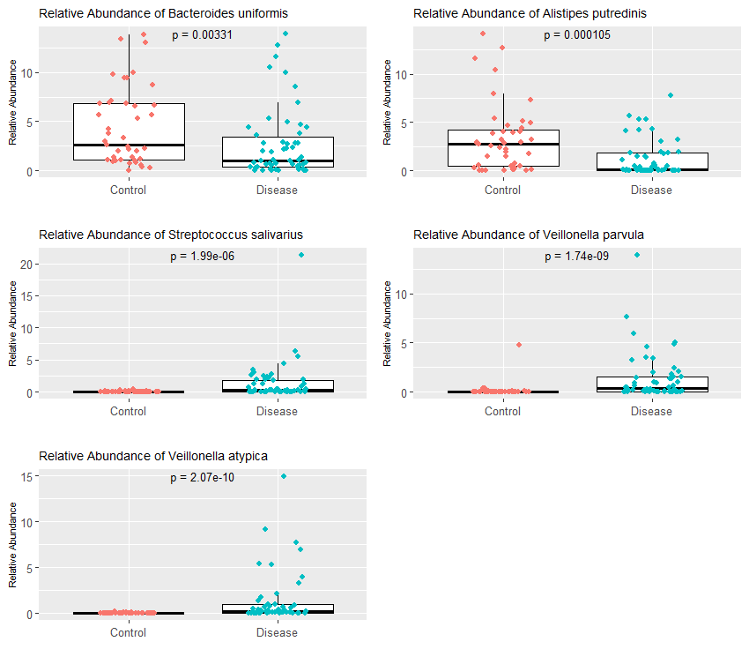

**Figure 6** - Boxplots showcasing the differential abundance of key species in liver disease in control (red) and diseased patients (blue).

**3.3 Analysis of Factors Associated with Liver Disease**

Additional factors potentially influencing the gut microbiome were evaluated in relation to liver disease. To achieve this, alpha diversity correlation calculations were conducted for age, gender, BMI, Alb, Crea, TB, and HBV data.

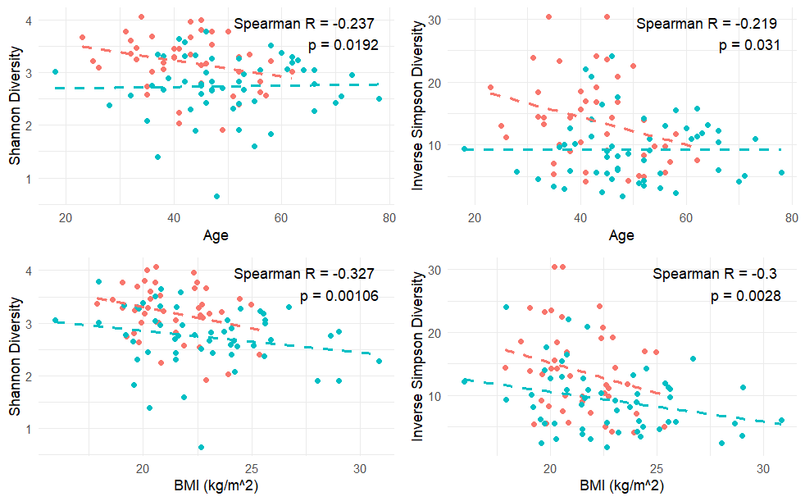

A)

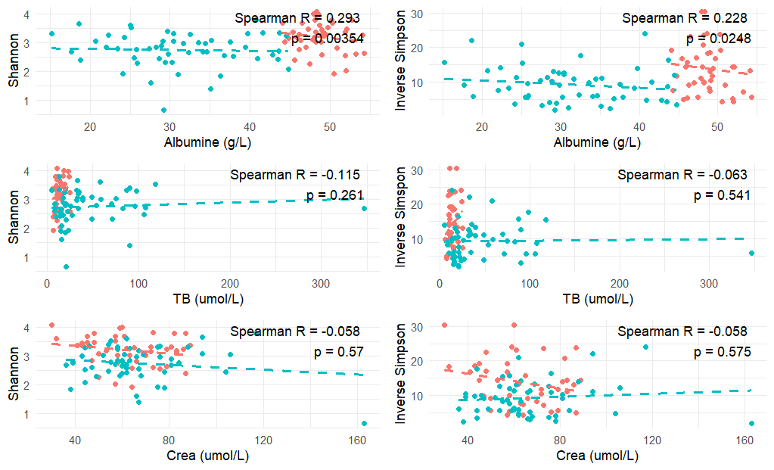

B)

**Figure 7** - Scatter plots of alpha-diversity and factor correlation using the Shannon and Inverse Simpson metrics. Each point represents a healthy (red) or diseased (blue) sample. Regression lines and p-values were calculated using Spearman’s correlation coefficients.

The scatter plots depicting alpha-diversity vs. age, utilizing the Shannon and Simpson metrics, reveal a negative slope for control patients (Figure 7A). This indicates that, in general, an increase in age is associated with decreased alpha-diversity. However, the barely positive slope observed for diseased patients suggests a slight increase in diversity with age. This trend remains inconclusive, and it may be attributed to the complex interplay between the progression of liver disease, the microbiota, and aging. Changes in liver function and the immune system over time could potentially affect individuals with liver disease differently as they age.

The negative slopes observed in both control and disease patients underscore a distinct relationship between BMI and alpha-diversity (Figure 7A). In both groups, higher BMI values are associated with decreased alpha-diversity, a pattern supported by the low p-values calculated with Spearman’s coefficients.

While there doesn't appear to be significance with creatinine and total bilirubin, the positive slope and low p-value observed in the alpha diversity versus albumin plot indicate the increase and significance of albumin levels in the context of liver disease (Figure 7B).

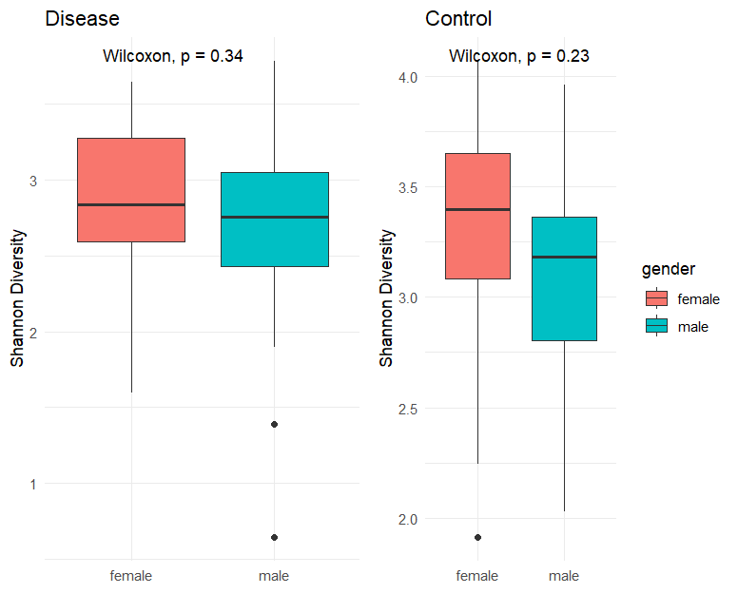

A) 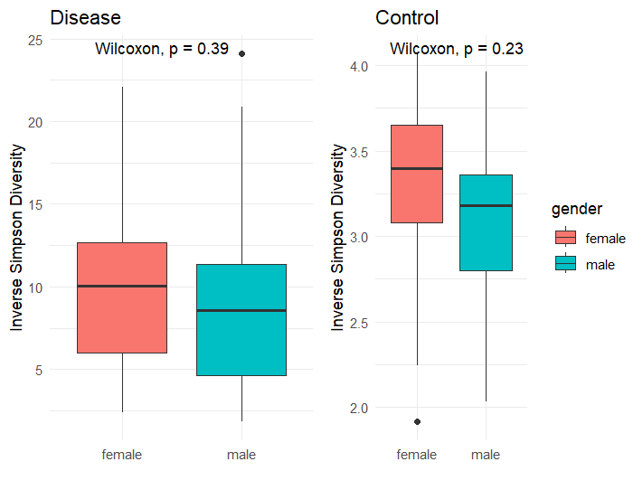

B) C)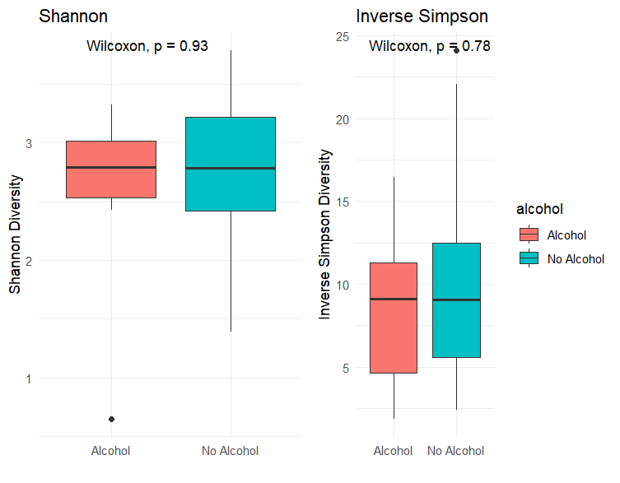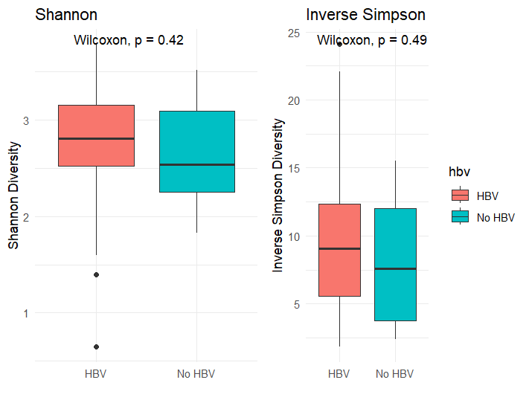

**Figure 8** - Boxplots illustrating the alpha-diversity of the gut microbiome across A) female (red) and male (blue) groups B) HBV (red) and no HBV (blue) groups C) alcohol (red) and no alcohol (blue) groups according to Shannon and Inverse Simpson indices.

Gender, HBV, and alcohol consumption were also investigated in relation to liver disease, but none of these factors stood out as significant, as indicated by their high p-values (Figure 8).

In addition to alpha diversity correlation, MELD score correlation was employed as another metric to assess the significance of the same factors in liver disease. Upon examination of these scatter plots and considering the insights gained from the alpha diversity plots, it can be asserted that BMI and albumin exhibit a clear significance in the occurrence and progression of liver disease.

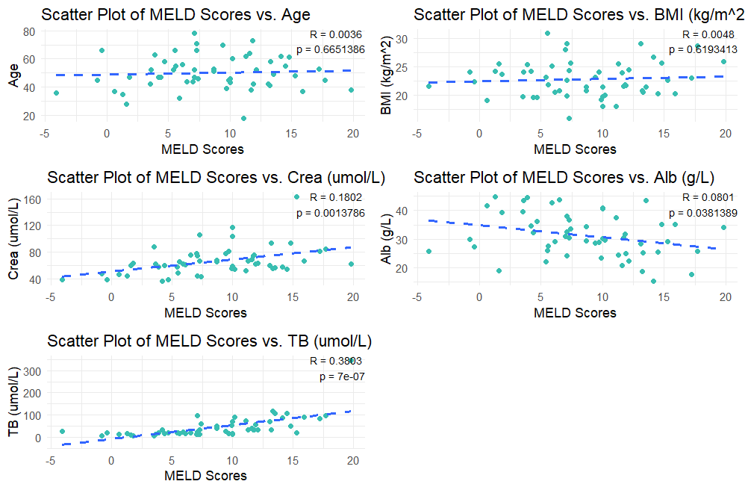

**Figure 9** - Scatter plots of age, BMI, creatinine, albumin, and TB in correlation with MELD scores from diseased patients.

**4 Discussion**

This study utilized whole-metagenome shotgun sequencing to profile the gut microbiome composition in both healthy individuals and those afflicted with liver disease, aiming to identify key species and factors associated with the condition. To achieve this, various statistical analyses were performed including alpha-diversity analysis, beta-diversity analysis, differential abundance analysis, and analysis of confounding variables.

**4.1 Key Species in Liver Disease**

Findings from these analyses suggest elevated levels of *Veillonella atypica*, *Veillonella parvula*, and *Streptococcus salivarius*, coupled with a decrease in *Alistipes putredinis* and *Bacteroides uniformis*, in the context of liver cirrhosis. These species are thereby emphasized as key components in the dysbiotic gut microbiome of individuals with liver disease.

General observations about the genera can also be made, suggesting potential associations between liver cirrhosis and increased levels of *Veillonella* and *Streptococcus*, along with a reduced abundance of the *Alistipes* genus.

*Alistipes* is a recently identified genus known for its ability to break down complex carbohydrates in the gut. Existing literature suggests a connection between the *Alistipes* genus and protection against certain diseases, including liver fibrosis[13](https://www.zotero.org/google-docs/?QtA0AD). Notably, a study by Iebba et. al (2018) indicated that a decrease in *Alistipes spp*. correlates with the progression of liver cirrhosis into the decompensated state [14](https://www.zotero.org/google-docs/?dwF4uW). In liver cirrhosis, the levels of *A. shahii* and *A. putredinis* were found to be decreased compared to healthy controls. Additionally, a reduction in *Alistipes* abundance has been observed in patients with liver fibrosis in other fibrotic diseases like NASH and NAFLD[15](https://www.zotero.org/google-docs/?U5OYEI). Despite its positive role in healthy phenotypes, *Alistipes* has been shown to have a contrasting pathogenic role in diseases such as anxiety, myalgic encephalomyelitis/chronic fatigue syndrome, and depression [13](https://www.zotero.org/google-docs/?aZWIZe).

*Bacteroides uniformis* is typically a dominant species in the gut microbiome, playing a crucial role in maintaining gut homeostasis, and is abundantly present in healthy individuals[16,17](https://www.zotero.org/google-docs/?1uQcz3). In instances of liver disease, there is evidence suggesting a decrease in the abundance of *B. uniformis*, contributing to the dysbiotic gut microbiome observed in affected patients[16](https://www.zotero.org/google-docs/?p45cPi). The low abundance in liver disease patients can thus be attributed to the dysbiotic composition in the gut, as evident by the alpha and beta diversity analyses.

The increased abundance of *Streptococcus* and *Veillonella* points to a particular trend in the translocation of oral bacteria to the gut, given their prevalence in the oral microbiome of healthy patients [18](https://www.zotero.org/google-docs/?SFZlsm). Recent studies provide additional support for the translocation theory by indicating an absence of evidence for the colonization of the gut by oral bacteria in healthy individuals [19,20](https://www.zotero.org/google-docs/?dUZeBG). The oral and gut microbiomes are anatomically linked through saliva and food, acting as mediums for this translocation. Kageyama et al. report aging as a significant factor in the translocation of oral bacteria to the gut, which prompts further exploration in the context of liver cirrhosis given the inconclusive results obtained from the correlation of age and liver disease [20](https://www.zotero.org/google-docs/?GUqZTe).

**4.2 Factors Associated with Liver Disease**

Typically, patients with liver cirrhosis exhibit reduced levels of albumin, and human serum albumin (HSA) is a frequent method of treatment for patients with liver cirrhosis [21](https://www.zotero.org/google-docs/?BCRtxo). However, results obtained from alpha diversity analysis (using Shannon and Inverse Simpson metrics) and MELD score correlation analysis contradict this phenomenon. Diseased patients in the data collected by Qin et al. exhibit elevated albumin levels in contrast to their healthy counterparts, indicating an additional complex interplay at play. Other health conditions or medications may be influencing albumin levels independently of liver function. Contribution to albumin production as an inflammatory response to chronic inflammations is another possibility for higher albumin levels in diseased patients [22](https://www.zotero.org/google-docs/?pD6cIz).

Alpha diversity analysis and the correlation analysis with the Model for End-Stage Liver Disease (MELD) score, conducted for Body Mass Index (BMI), produce results consistent with existing literature. Elevated BMIs are indicative of an elevated risk of liver disease, particularly non-alcoholic fatty liver disease (NAFLD). A 2021 cross-sectional study focusing on obese adolescents (BMI > 30 kg/m2) concludes that individuals with NAFLD and higher BMIs face an elevated risk of developing liver fibrosis compared to those with lower BMIs [23](https://www.zotero.org/google-docs/?L3EOmD). A meta-analysis examining obesity as a prognostic factor for liver disease echoes similar findings, highlighting the association between obesity and an increased risk of severe liver disease[24](https://www.zotero.org/google-docs/?pDt565).

**4.3 Future Works**

When navigating the trajectory for future research, it becomes crucial to pinpoint gaps in knowledge, emerging trends, and evolving challenges within the current research landscape. This section delves into potential trajectories and areas of exploration that require further investigation.

Future research should prioritize the sampling of whole-metagenomic shotgun data with enhanced population diversity, as all the samples collected by Qin et al. are exclusively from the Chinese population. Increased population diversity offers several benefits, including a broader understanding of the microbial landscape and the potential to uncover variations across diverse genetic backgrounds and environmental exposures.

Furthermore, further investigations aimed at comprehending the biological mechanisms underlying the observed correlations could elucidate the trends identified in the results. Conducting additional investigations to unravel the biological mechanisms behind observed correlations would provide insights into the involvement of immune and metabolic factors and their influence on the correlated species.

And lastly, given the absence of an enhanced cure for liver cirrhosis, it is crucial to contemplate alternative therapeutic approaches that can inform and guide further research. Exploring strategies for targeting the gut microbiome could offer valuable insights into preventing and slowing disease progression.

**6 Conclusion**

In conclusion, this study sheds light on the relationship between the gut microbiome and liver cirrhosis, identifying key species and factors associated with the disease. Notably, the *Alistipes*, *Veillonella*, *Streptococcus* genera, and *Bacteroides uniformis* play crucial roles in the dysbiotic gut microbiome observed in liver disease patients. Additionally, BMI and albumin emerged as significant factors, challenging conventional expectations and demanding further exploration for the latter. The findings emphasize the need for enhanced population diversity in future research and underscore the importance of investigating biological mechanisms and alternative therapeutic approaches for a more holistic understanding and effective management of liver cirrhosis.

**References**

[1. Lee, N. Y. & Suk, K. T. The Role of the Gut Microbiome in Liver Cirrhosis Treatment. *Int. J. Mol. Sci.* **22**, (2020).](https://www.zotero.org/google-docs/?KoCezR)

[2. Qin, N. *et al.* Alterations of the human gut microbiome in liver cirrhosis. *Nature* **513**, 59–64 (2014).](https://www.zotero.org/google-docs/?KoCezR)

[3. Albillos, A., de Gottardi, A. & Rescigno, M. The gut-liver axis in liver disease: Pathophysiological basis for therapy. *J. Hepatol.* **72**, 558–577 (2019).](https://www.zotero.org/google-docs/?KoCezR)

[4. Smith, A., Baumgartner, K. & Bositis, C. Cirrhosis: Diagnosis and Management. *Am. Fam. Physician* **100**, 759–770 (2019).](https://www.zotero.org/google-docs/?KoCezR)

[5. Jepsen, P. & Younossi, Z. M. The global burden of cirrhosis: A review of disability-adjusted life-years lost and unmet needs. *J. Hepatol.* **75**, S3–S13 (2021).](https://www.zotero.org/google-docs/?KoCezR)

[6. Guan, H., Zhang, X., Kuang, M. & Yu, J. The gut–liver axis in immune remodeling of hepatic cirrhosis. *Front. Immunol.* **13**, (2022).](https://www.zotero.org/google-docs/?KoCezR)

[7. Yan, A. W. *et al.* Enteric Dysbiosis Associated with a Mouse Model of Alcoholic Liver Disease. *Hepathology* **53**, 96–105 (2011).](https://www.zotero.org/google-docs/?KoCezR)

[8. Bajaj, J., Heuman, D. & Hylemon, P. Altered profile of human gut microbiome is associated with cirrhosis and its complications. *J Hepatol* **940**, 940–947 (2013).](https://www.zotero.org/google-docs/?KoCezR)

[9. Bajaj, J. S. Altered Microbiota in Cirrhosis and Its Relationship to the Development of Infection. *Clin. Liver Dis.* **14**, 107–111 (2019).](https://www.zotero.org/google-docs/?KoCezR)

[10. Loomba, R. *et al.* Gut Microbiome-Based Metagenomic Signature for Non-invasive Detection of Advanced Fibrosis in Human Nonalcoholic Fatty Liver Disease. *Cell Metab.* **25**, 1054–1062 (2017).](https://www.zotero.org/google-docs/?KoCezR)

[11. Durazzi, F. *et al.* Comparison between 16S rRNA and shotgun sequencing data for the taxonomic characterization of the gut microbiota. **11**, (2021).](https://www.zotero.org/google-docs/?KoCezR)

[12. Blanco-Miguez, A. *et al.* Extending and improving metagenomic taxonomic profiling with uncharacterized species using MetaPhlAn4. *Nat. Biotechnol.* (2023) doi:https://doi.org/10.1038/s41587-023-01688-w.](https://www.zotero.org/google-docs/?KoCezR)

[13. Parker, B. J., Wearsch, P. A., Veloo, A. C. M. & Rodriguez-Palacios, A. The Genus Alistipes: Gut Bacteria With Emerging Implications to Inflammation, Cancer, and Mental Health. *Front. Immunol.* **11**, (2020).](https://www.zotero.org/google-docs/?KoCezR)

[14. Iebba, V. *et al.* Combining amplicon sequencing and metabolomics in cirrhotic patients highlights distinctive microbiota features involved in bacterial translocation, systemic inflammation and hepatic encephalopathy. *Nature* doi:10.1038/s41598-018-26509-y.](https://www.zotero.org/google-docs/?KoCezR)

[15. Rau, M. *et al.* Fecal SCFAs and SCFA-producing bacteria in gut microbiome of human NAFLD as a putative link to systemic T-cell activation and advanced disease. *United Eur. Gastroenterol J.* **6**, (2019).](https://www.zotero.org/google-docs/?KoCezR)

[16. Korobeinikova, A. V., Zlobovskaya, O. A. & Sheptulina, A. F. Gut Microbiota Patterns in Patients with Non-Alcoholic Fatty Liver Disease: A Comprehensive Assessment Using Three Analysis Methods. *Int. J. Mol. Sci.* **24**, (2023).](https://www.zotero.org/google-docs/?KoCezR)

[17. Yan, Y. *et al.* Bacteroides uniformis-induced perturbations in colonic microbiota and bile acid levels inhibit TH17 differentiation and ameliorate colitis developments. *Nature* **9**, (2023).](https://www.zotero.org/google-docs/?KoCezR)

[18. Yuan, H. *et al.* Quantitative changes of Veillonella, Streptococcus, and Neisseria in the oral cavity of patients with recurrent aphthous stomatitis: A systematic review and meta-analysis. *Arch. Oral Biol.* **129**, (2021).](https://www.zotero.org/google-docs/?KoCezR)

[19. Rashidi, A., Ebadi, M., Weisdorf, D. J., Costalonga, M. & Staley, C. No evidence for colonization of oral bacteria in the distal gut in healthy adults. *Proc. Natl. Acad. Sci. U. S. A.* **118**, (2021).](https://www.zotero.org/google-docs/?KoCezR)

[20. Kageyama, S. *et al.* High-Resolution Detection of Translocation of Oral Bacteria to the Gut. *J. Dent. Res.* **102**, 752–758 (2023).](https://www.zotero.org/google-docs/?KoCezR)

[21. Arroyo, V., Garcia-Martinez, R. & Salvatella, X. Human serum albumin, systemic inflammation, and cirrhosis. *J. Hepatol.* **61**, 396–407 (2014).](https://www.zotero.org/google-docs/?KoCezR)

[22. Bernardi, M., Angeli, P., Claria, J. & Moreau, R. Albumin in decompensated cirrhosis: new concepts and perspectives. *Gut* **69**,.](https://www.zotero.org/google-docs/?KoCezR)

[23. Moran-Lev, H., Cohen, S., Webb, M. & Yerushalmy-Feler, A. Higher BMI predicts liver fibrosis among obese children and adolescents with NAFLD - an interventional pilot study. *BMC Pediatr.* **21**, (2021).](https://www.zotero.org/google-docs/?KoCezR)

[24. Jarvis, H., Craig, D., Barker, R., Spiers, G. & Stow, D. Metabolic risk factors and incident advanced liver disease in non-alcoholic fatty liver disease (NAFLD): A systematic review and meta-analysis of population-based observational studies. *PLOS Med.* **17**,.](https://www.zotero.org/google-docs/?KoCezR)